Thursday 12th February 2026 at 18:00 UTC

In-Person at

Institution of Civil Engineers, One Great George Street,

London, SW1P 3AA
Collapsed Segmental Lined Tunnel and its Recovery
Speakers:
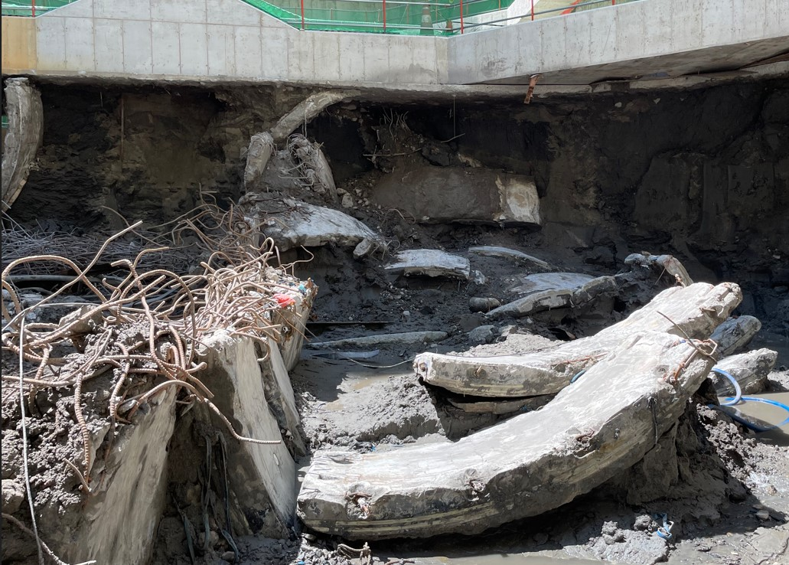
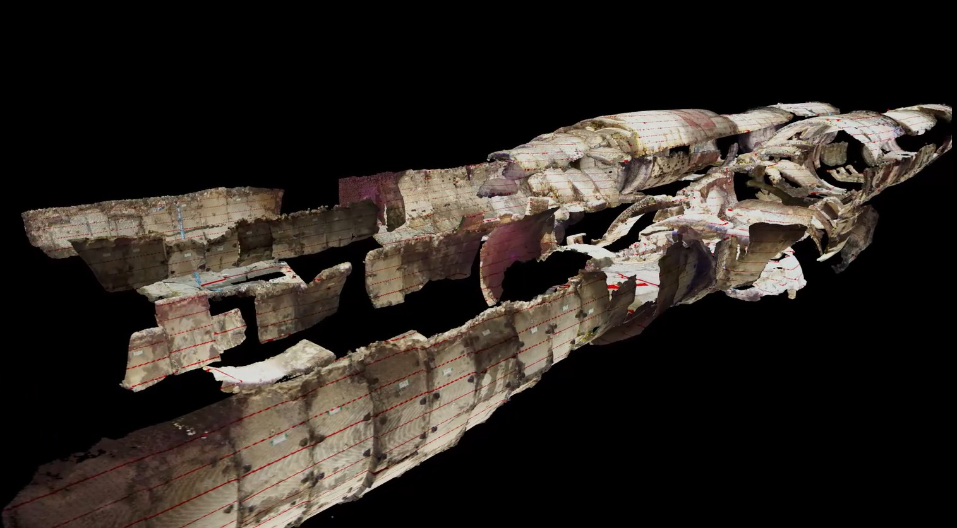
Hyuk-il Jung – Associate Director, Arup

A twin bored, segmentally lined tunnel being constructed in soft marine deposit ground completely collapsed in March 2020 during cross-passage construction.
Due to the soft ground conditions, the area at the cross-passage location was pre-treated with grout prior to tunnel boring machine (TBM) operations. Subsequently, cross-passage construction commenced using an open-face excavation methodology.
During excavation, a small area at the excavation face began leaking water, accompanied by flowing silt and sand. This eventually led to a catastrophic collapse.
This lecture will summarise the timeline of the collapse event and explain the mechanism of the tunnel failure as observed during the incident.
It will also present the emergency mitigation measures taken by the contractor, along with the recovery methods adopted to rebuild the collapsed section of the tunnel.

Note 1: This is an in-person lecture but will also be streamed live on Zoom.
Note 2: Pre-registration for in person attendance is preferable on the ICE Website.
Note 3: Tea & coffee will be served downstairs from 17:30 hrs onwards.
Note 4: Post-lecture food & drinks, sponsored by Arup, will be served in the ICE bar.

